

INFORMATION TECHNOLOGY EDUCATION DEPARTMENT

ITPROG2
(Computer Programming 2 for IT)

EXERCISE
1

One-D Array

score

Guillermo, Justine Rome M.  Name of Student | Lalata, Jay Ar  Name of Professor
01/04/19  Date Performed | 01/04/19  Date Submitted

SUPPLEMENTARY PROBLEMS

1. Write a program that reads ten (10) integers into an array, computes the average, largest and smallest number in the array.

Expected Output:

Enter ten numbers: 2 3 6 8 10 9 7 13 4 8
The average of the numbers is 7.
The largest number is 13.
The smallest number is 2.

Program:
#include <iostream>
using namespace std;

int main(){

int i, num[10], ave = 0 , min , max , sub = 0;
cout<<"Enter Ten Numbers: ";
for(i=0; i < 10; i++){
cin>>num[i];
}{
min = num[0];
max = num[0];
for(i=0; i < 10; i++){
sub = num[i];
if( sub <= 2)
min = sub;

if( sub > max)
max = sub;
}}
for(i=0; i < 10; i++){
ave+=num[i];
}
ave = ave / 10;
cout<<"ave : "<<ave<<endl;
cout<<"max : "<<max<<endl;
cout<<"min : "<<min;

}

Screen Output:

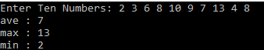

2. Make a program that reads a sentence then count the number of vowels, consonants, symbols (comma and period only), words and spaces.

Expected Output:

Enter a sentence: I love you JV.
There is/are 5 vowel(s), 5 consonant(s) and 1 symbol(s).
In the given sentence, it contains 4 word(s) and 3 space(s).

Program:
#include <iostream>
using namespace std;

int main()
{
char line[150];
int vowels, consonants, symbol, spaces;

vowels = consonants = symbol = spaces = 0;

cout << "Enter your sentence: ";
cin.getline(line, 150);
for(int i = 0; line[i]!='\0'; ++i)
{
if(line[i]=='a' || line[i]=='e' || line[i]=='i' ||
line[i]=='o' || line[i]=='u' || line[i]=='A' ||
line[i]=='E' || line[i]=='I' || line[i]=='O' ||
line[i]=='U')
{
++vowels;
}
else if((line[i]>='a'&& line[i]<='z') || (line[i]>='A'&& line[i]<='Z'))
{
++consonants;
}
else if(line[i]>='.')
{
++symbol;
}
else if (line[i]==' ')
{
++spaces;
}

}

cout << "Vowels: " << vowels << endl;
cout << "Consonants: " << consonants << endl;
cout << "Symbol: " << symbol << endl;
cout << "Spaces: " << spaces << endl;
cout << "Words:" <<++spaces;

return 0;
}

Screen Output: (provide two examples)

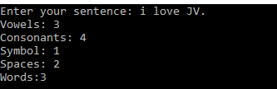
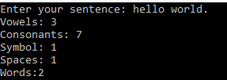

3. Create a program that will check if a given word is a palindrome or not a palindrome.

EXAMPLE PROGRAM OUTPUT:
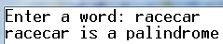 | 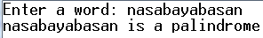
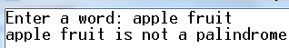 | 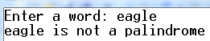

Program:

#include <iostream>
using namespace std;

int main(){
string x;
int s;
bool z = true;

cout<<"Enter a word: ";

getline(cin,x);

s = x.length();

for (int i = 0;i < (s / 2); i++)
{
if (x[i] != x[(s - 1)-i])
z = false;
}
if (z == true)
cout<<x<<" is a palindrome."<<endl;

else
cout<<x<<" is not a palindrome.";

return 0;
}

Screen Output: (provide two examples)
